All vm’s up and running

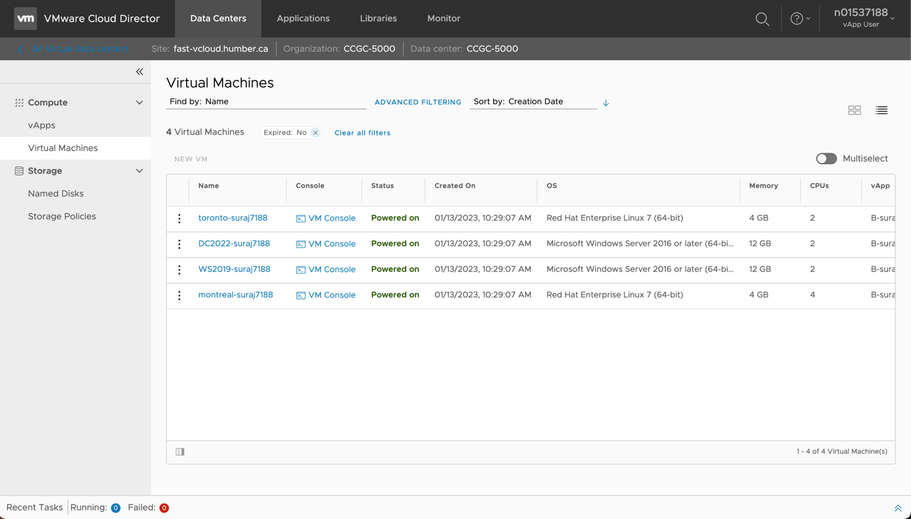

Montreal grep

Toronto grep

Toronto Hostname

Montreal Hostname

History1

History 2

